J3ZZ Vibrotanica Workshop - Tech rider (english) -– STEREO
Last updated : 24.10.2023 - vibrotanica@j3zz.com

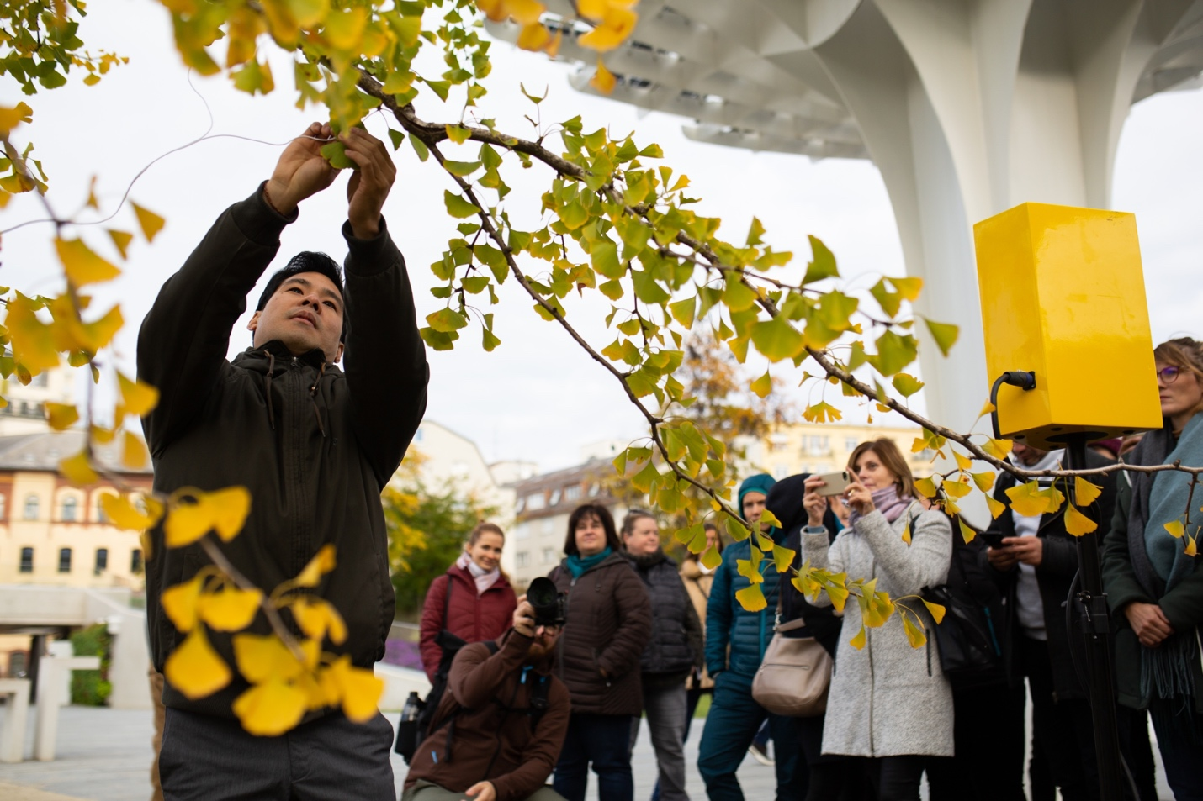
First of all, thank you for your interest in booking a workshop for J3ZZ Vibrotanica. Below is a list of our technical requirements. It might sound a bit formal to you, this is not meant to cause any inconveniences on your behalf. We designed this rider for optimum effectiveness at the day of the show. If there are any questions or if you have trouble providing any of the below mentioned please get in touch with us before the day of the show and we will work out a solution.

Stage Set up

Jérôme Li-Thiao-Té - Main Artist, Mic speaker. (L) - Manager +33 (0)6 98 84 55 71.
Jérôme Ringana (on Réunion island) - Sound engineer FOH. (XL)
Aric Resnick (outside of Réunion island) - Sound engineer FOH. (XL)

Microphones, cables, speakers, DI and arm stands etc.

FOUR (4) battery-powered Bluetooth speakers or with a 3,5mm TRS aux in connection
FOUR (4) 3,5mm TRS jack male – 3,5mm TRS jack male cables
ONE (1) laptop Direct Box RADIAL Stagebug (or Equivalent)
ONE (1) 6,5mm TRS jack male – XLR male cable
ONE (1) XLR male – XLR male cable
THREE (3) 6,5mm TRS jack male – 6,5mm TRS jack male cable
TWO (2) tables 2,5m x 1,5m

Workshop plot
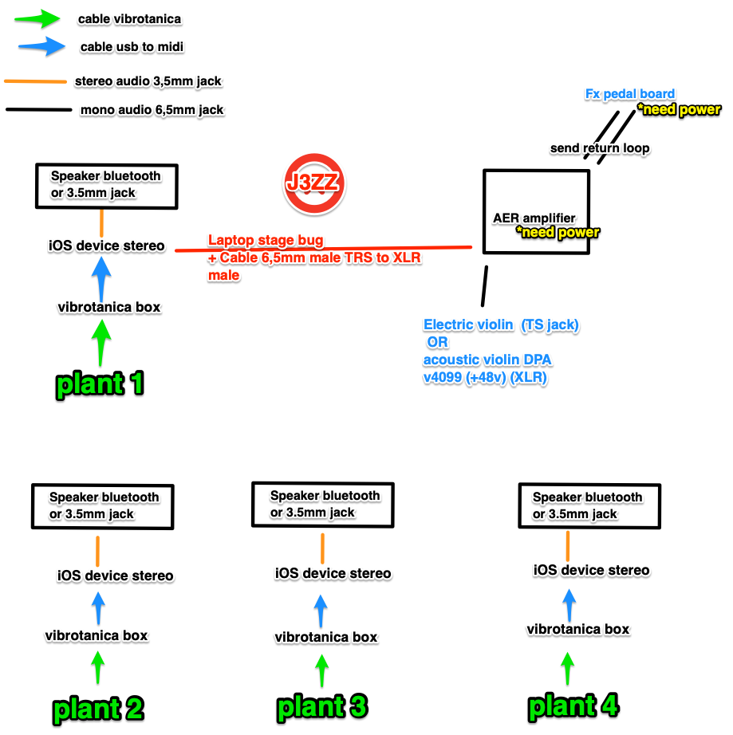

Backline Requirements

Artist stage needs:
ONE (1) STANDING HEIGHT 90 CM table with black covering 160-200 wide x 80cm deep
A sober English-speaking AV Technician who is experienced with the equipment and is to be available to assist for the duration of the artist’s visit to the venue.
All system control must be visible to our engineer if we are traveling with If not we will depend on the house staff for Sound, video, and lighting support.

Required green Plants :
The venue is required to provide four vivid plants with unwaxed leaves for the artist to set up the vibrotanica flat surface sensors (2.5 cm x 2.5 cm) on. The leaves should be completely natural and wide enough to accommodate the sensors. The plants should be large enough to be visible to the audience.

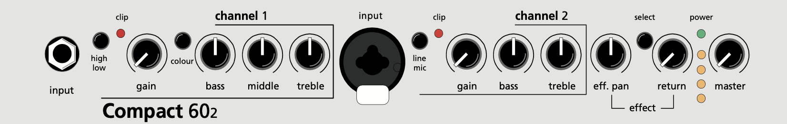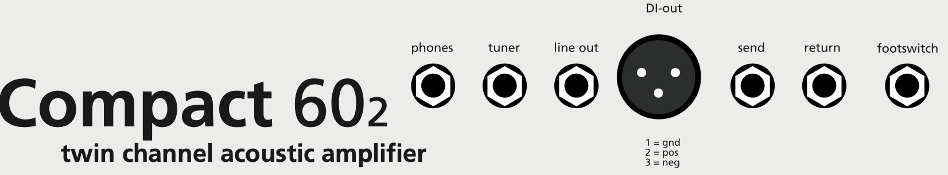

Out | In | units | 6 chargers
 |  | 4 | Vibrotanica box + TENS cables + sensors
 |  | 4 | iOS device + charger lightening + lightning cable
 |  | 1 | Cable XLR -XLR
 |  | 3 | Cable TRS stereo 3,5mm - TRS stereo 3,5mm
 |  | 1 | Cable TRS stereo 6,5mm jack – XLR femelle
 |  | 3 | Cable TS mono 6,5mm - TS mono 6,5mm
 |  | 4 | Cable UM-ONE Roland Midi – USB + Apple camera kit usb
 |  | 4+4 | Bluetooth speaker + charger
 |  | 1 | RADIAL DI Stage bug
 |  | 1 | electric violin
 |  | 1 | Violin (acoustic)
 |  | 1 | Violin stand
 |  | 1 | Dpa 4099v
 |  | 1 | Akg B29L + C411L
 |  | 1 | Pedal board
 |  | 1 | power strip
 |  | 1 | AER COMPACT 60-2 + IEC cable
 |  | 1 | Camera INSTA360 + selfie stick + apple charger + apple usb-c cable
 |  | 1 | Manfrotto tripod

